Biodata: Professor Irene Ng
Irene Ng is the Professor of Marketing and Service Systems and Director of the International Institute of Product and Service Innovation (IIPSI) at WMG, University of Warwick, UK. She holds a PhD specialising in pricing and economic models for service and an undergraduate degree in Physics, both from the National University of Singapore.
For 16 years, Irene was an entrepreneur. In 1989, with very little capital, she took over an ailing SA Tours, one of the largest tour operators in Southeast Asia and turned it around by diversifying into cruises. In 1994, she pioneered year-round cruising in the region, and went on to start up Empress Cruise Lines (ECL) with USD5 million of private equity. By the time she sold ECL in 1996, she had built it into a venture of USD250 million annual turnover.
Her change of career to become an academic in 1997 has led to global recognition for her work in value, new business models and service systems with more than 22 international journal articles, two books and over 50 conference proceedings in the domain of engineering, management, marketing, information systems, economics, education and sociology. As a business academic, she has held more than £7.8m worth of multi-disciplinary scientific grants since 2008 as a Principal and Co-Investigator. Her new book ‘Value and Worth: Creating New Markets in the Digital Economy’ has just been released on Amazon Kindle (http://www.amazon.com/dp/B00ARK1LSI). She is also one of the 4 investigators of NEMODE, (New Economic Models in the Digital Economy) a £1.5m initiative under the Research Councils UK (RCUK)’s Digital Economy (DE) Network+ programme. She is also the author of The Pricing & Revenue Management of Services: A Strategic Approach published by Routledge, and the lead editor of Complex Engineering Service Systems: Concepts and Research published by Springer
Irene received recognition for her work when she was appointed one of six UK ESRC Advanced Institute of Management (AIM) Research Services Fellows in 2008, and when she became the ESRC/NIHR Placement Fellow and academic advisor to the Cambridge University Health Partners in 2009. She was also appointed a Visiting Fellow of Wolfson College Cambridge in the same year. Irene joined WMG at the University of Warwick in September 2011, where she is tasked to grow WMG's capability of impactful and cutting edge research and leading practice in the business and management of service systems and digital innovation. She was appointed the Director of IIPSI in September 2012.
Irene continues to work actively with industry, small and large. She has collaborated with organisations such as GlaxoSmithKline, Rolls-Royce, BAE Systems, IBM, and the Ministry of Defence, and she advises start-ups on new pricing and economic models. As Director of IIPSI at WMG, Irene combines her research in value and markets with her entrepreneurial practice experience to focus on scaling IIPSI’s capability as an innovation ecosystem to create new jobs and start-ups in digital technology.
To access Irene's institutional pages, please visit http://go.warwick.ac.uk/sswmg. For her personal research papers, please visit: http://www.ireneng.com

About WMG and the International Institute for Product and Service Innovation (IIPSI) (http://www2.warwick.ac.uk/fac/sci/wmg/iipsi/)
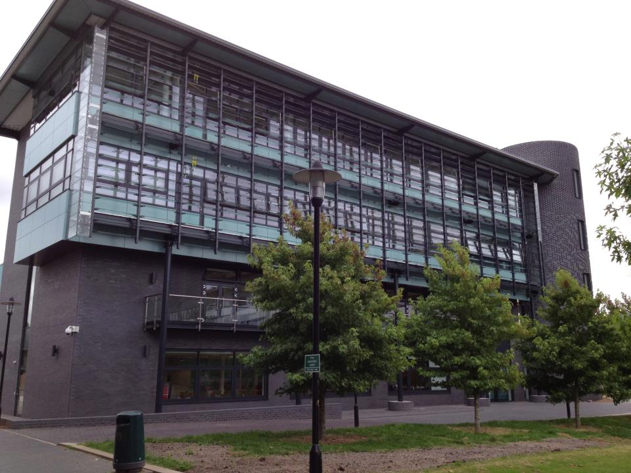
WMG is an internationally leading group focused on improving competitiveness of organisations through innovation, technologies and skills, and bringing academic rigour to organisational practice. An independent, interdisciplinary academic department of the University of Warwick, WMG has over 300 staff and a research grant and contracts portfolio (primarily EPSRC, TSB, EU and industry) of £52m (live projects), including an EPSRC Industrial Doctorate Centre. WMG Digital is an Innovation ecosystem platform to achieve impact in the digital economy with activities from cutting edge research through to pre-incubation of start-ups and commercialisation of technology. IIPSI is the newest institute of WMG. It is European Regional Development Fund (ERDF), and university- funded state-of‐the‐art facility, a building showcasing the technology demonstrators of WMG’s core research areas: Digital Innovation; Polymer Innovation and Experience Led Innovation. A unique feature of IIPSI is the presence of a business research team focusing on value, service systems and new business models, headed by IIPSI director Professor Irene Ng. Professor Ng’s team is engaged in cutting edge business research for publications but also serve to transfer knowledge of its research to bootstrap IIPSI’s 3 technology-focused research and assist in creating unique business and market-led propositions. IIPSI has 7 dedicated knowledge transfer SME team focused on boosting R&D capacity and competitiveness within small businesses; since the initiative began 2 years ago, it has created 12 new high tech start‐up businesses, directly generated 70 new jobs, and trained over 450 small business in a range of digital technologies over the last four years.

